INTERNATIONAL FUND: *application*

Support of an international activity

within a Master’s program at the

faculty for Geosciences and Geography, Uni Göttingen

Our international fund aims at supporting students of our faculty who are enrolled in one of our MSc programs and who plan an international activity in context with their degree course or thesis work that improves their international visibility.

The activity must serve the professional development and may promote the MSc thesis work. This includes international conferences, workshops and field work abroad but excludes group activities such as guided field trips as well as activities within third-party funded projects. Funds of up 1000 € can be obtained once within the MSc program. Costs will be refunded upon submission of receipts within six months after the event. In the case of field work, costs for travel and accommodation can be reimbursed, but food, work clothing and similar items cannot.

To apply send your application using this template via e-mail to the office of academic affairs (studiendekanat@geo.uni-goettingen.de). The application deadlines are on the first day of March, June, September and December. You will be notified about the decision on your application within circa four weeks of the deadlines.

**Name, first name(s): ______________________ Date of birth: _______________________**

**Matriculation No.: ________________________ Semester (within MSc program): _______**

**Street: __________________________________ City: _______________________________**

**Phone: _________________________________ E-Mail: _____________________________**

**Finanzamt: ______________________________ Tax ID: _____________________________**

**Bank account no: _________________________ Bank: ______________________________**

**BLZ: ____________________________________ IBAN: ______________________________**

**Title of activity: ____________________________________________**

**Place of the activity (country, city): ____________________________**

**Dates of the activity (from-to): ________________________________**

**Estimated costs (attach a quote if possible): _____________________**

**Supervisor (of your MSc thesis): _______________________________**

**Outline the project on half a page:**

**_____________________________**

(Date and signature)

**Consent by supervisor**

*I confirm that the proposed activity promotes the studies and professional development of the applicant and that this activity is not associated with a third-party funded project of the supervisor.*

**_____________________________**

(Signature of supervisor and seal)

**Following the activity**: For refunds send proof of participation and receipts of fees/travel costs etc. to [studiendekanat@geo.uni-goettingen.de](mailto:studiendekanat@geo.uni-goettingen.de) including the signed page 3 below. Note that the “Niedersächsliche Reisekostenrecht” applies. Please send your request in a timely manner (at best within a few weeks).

INTERNATIONAL FUND*: refund*

**Name, first name(s): _____________________ Date of birth: _______________________**

**Matriculation No.: _______________________ Semester (within MSc program): ________**

**Supervisor (of your MSc thesis): ______________________________**

**Place of the activity (country, city): ____________________________**

**Title of activity: ____________________________________________**

**Dates of the activity (from-to): ________________________________**

**Total refunds requested (attach all receipts): ____________________**

***Pls note:*** In the case of field work, costs for travel and accommodation can be reimbursed, but food, work clothing and similar items cannot.

**Confirmation:**

*Hereby, I confirm that I only request refunds for actual costs and that all requested refunds are claimed only once.* *Attached I send receipts for payments of expenses incurred exclusively by me. I have indicated if costs were disbursed by others.*

***____________________________________***

(Date and signature)

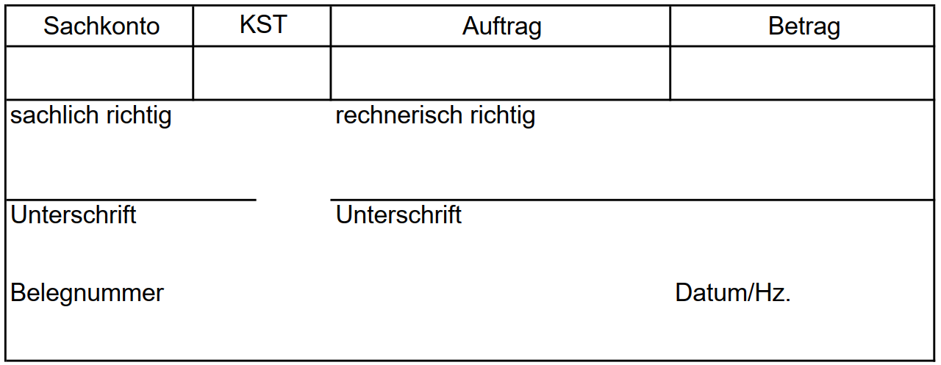**To be filled by the dean of studies office:**